**ASSIGNMENT-02**

**DATA VISUALIZATION AND PRE PROCESSING**

|  |  |
| --- | --- |
| **Assignment Date** | 22 September 2022 |
| **Student Name** | Manjusri P |
| **Student Roll Number** | 113219071017 |
| **Maximum Marks** | 2 Marks |

1. Download the dataset: Dataset downloaded in csv form.
2. Load the dataset.

import pandas as pd

ds = pd.read_csv("/content/drive/MyDrive/IBM/Churn_Modellin g.csv")

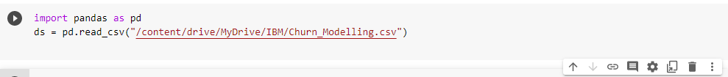

1. Perform Below Visualizations.

* Univariate Analysis

sn.displot(ds['Gender'])



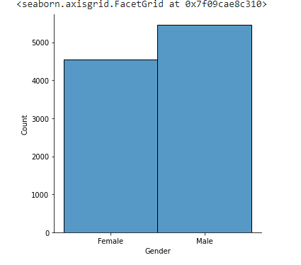

* Bi - Variate Analysis sn.boxplot(ds['CustomerId'],ds['Age'])

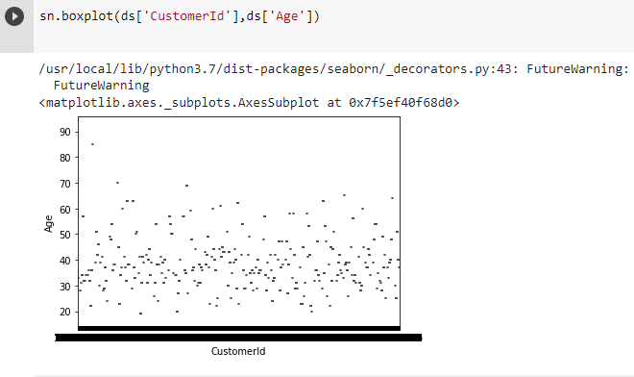

* Multi - Variate Analysis

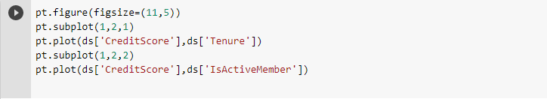

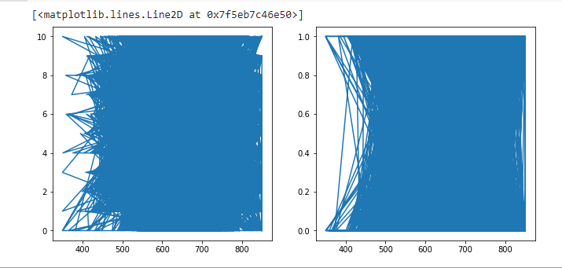

1. Perform descriptive statistics on the dataset.

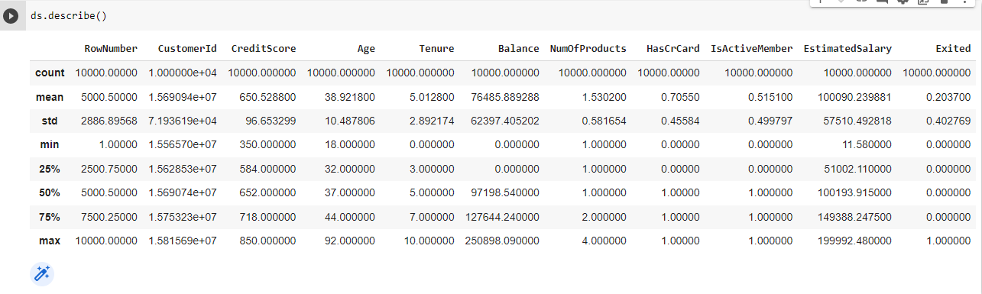

Mean:

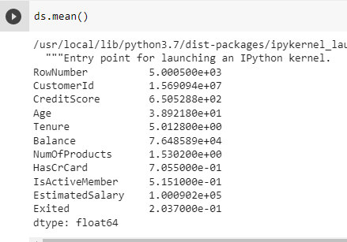

1. Handle the Missing values.

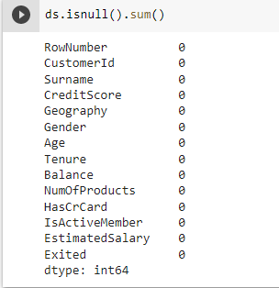

1. Find the outliers and replace the outliers

Finding Outliers:

Using Boxplot

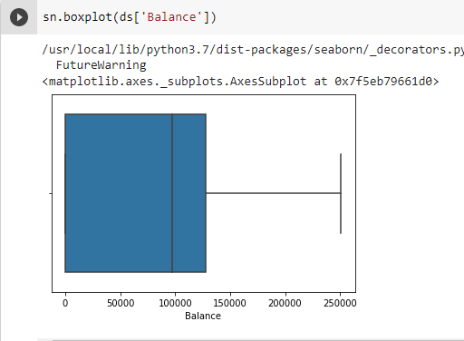

Using method

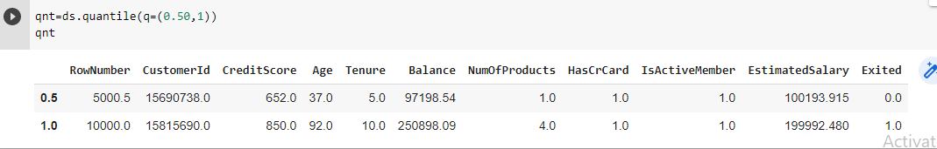

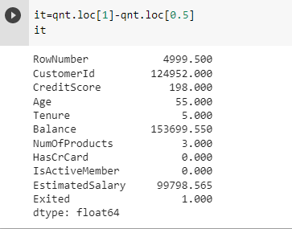

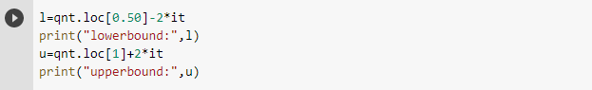

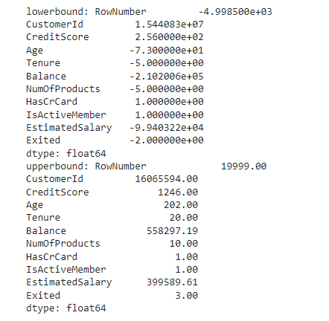

Replacing Outliers:

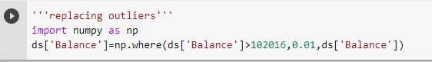

1. Check for Categorical columns and perform encoding.

Categorical columns: CreditScore,Geography

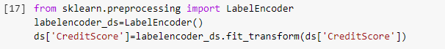

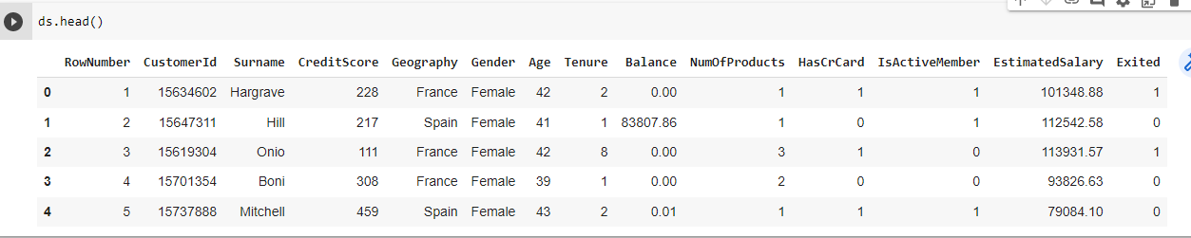

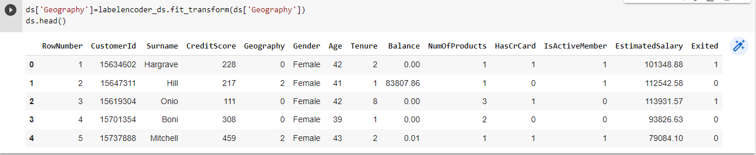

1. Split the data into dependent and independent variables.

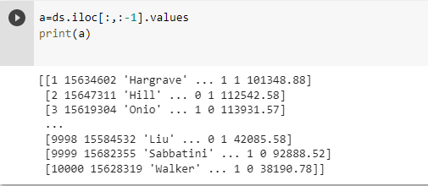

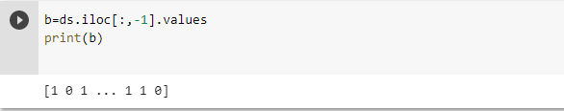

1. Scale the independent variables

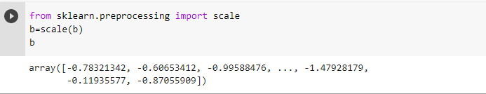

1. Split the data into training and testing

b_train



b_test



a_train

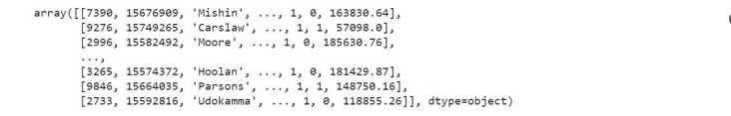

a_test

